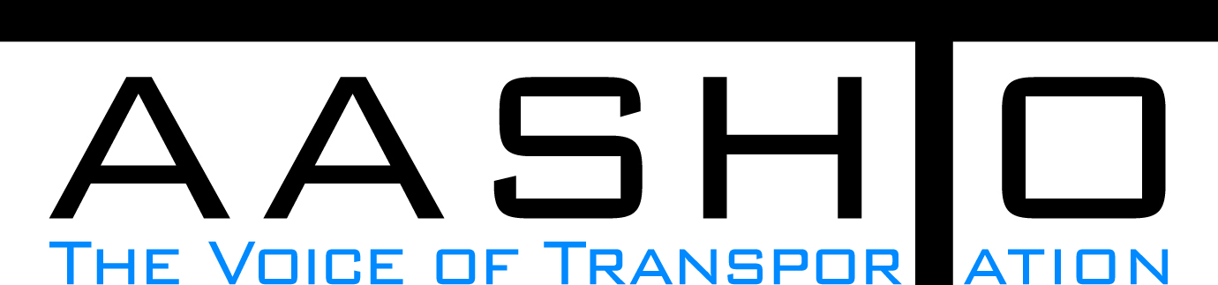Domestic Scan Proposal Form
AASHTO is soliciting topic proposals for a Calendar Year 2014 US Domestic Scan Program (NCHRP Panel 20-68A). Each selected scan topic will be investigated through site visits to three to six locations for approximately a two week period or less (type 1), by webinar, (type 2) peer exchange, or (type 3) conducted by a group of eight to 12 transportation professionals with expertise in the selected topic area. Proposed topics should meet the following criteria:
- Address an important and timely need for information by transportation agencies;
- Are of interest to a broad national spectrum of people and agencies;
- Are complex and also “hands-on,” meaning they lend themselves particularly well to exploration through on-site visits; and
- Are sufficiently focused that the tour participants are able to investigate and understand key issues in the limited time available on the tour.

Before submitting your proposal it is highly recommended that you read What Makes a Good Scan Topic Proposal http://www.domesticscan.org/what-makes-a-good-scan-topic-proposal
This form is designed to collect the full length of your proposal. Sections requiring essays have unlimited space for you to use. Contact information has some limited text. Use your TAB→ key to advance to the area where you need to complete information.
Proposals should be returned no later than OCTOBER 15, 2013.
IMPORTANT NOTE on How to save your document: LastNameFirst Initial, underscore_Organization Acronym _CY2014.
Saved Document Name Example: VitaleM_AASHTO_CY2014
If you have more than one, add a number after first initial: VitaleM1_AASHTO_CY2014

Domestic Scan Proposal Contact Information
Name | TODD JENSEN | Address | 4501 S. 2700 W.  P. O. Box 148380  Salt Lake City, UT 84114-8380
Title | Statewide Quality Manager | E-mail | toddjensen@utah.gov
Member Department | UDOT | Telephone number | (801) 965-3866
AASHTO Committee |  | Date of submission | 9/26/2013

Title of Proposed Scan: Best Practices In States / Organizations With Successful Quality Plans and Programs

Problem Statement (What topic is to be examined? What drives the need for the scan? Why now?)
The need for effective quality management systems is more critical now than ever as State DOTs across the country are being asked to produce more with the same or fewer resources.
DOTs have traditionally focused on three major components for projects; scope, schedule and budget. Given the responsibility of transparency and accountability for tax dollars expended on roadways - quality should be added as a fourth component of focus.
Tax dollar accountability is parallel to a private organization’s responsibility to shareholders for maximizing their return on investment. The return on investment is reinvested in products, services, human resources, equipment, technology, and into the organization to create improved products and services that entice customers to buy more of the organization’s products. A quality management system is used in successful private organizations to manage this system of expenditures and production. State DOTs, like private organizations, have a need to develop quality management systems to manage expenditures and production.
State DOTs can benefit from examining and understanding quality management systems that are currently being implemented in successful private organizations and other DOTs across the country.

Scan Scope (What specific subject areas are to be examined? Which cities and states might be visited? Which agencies/organizations (including specific departments or types of staff if applicable)?
1) Proposed Scan scope subject areas
a) Preconstruction quality processes
b) Construction quality processes

2) Proposed agencies/organizations to visit
a) Parsons Brinkerhoff
b) URS
c) AECOM
d) Parsons
e) HDR
f) The Ross Group Construction Corp.
g) Los Angeles County Metropolitan Transportation Authority
h) Illinois Department of Transportation
i) Florida Department of Transportation
j) Virginia Department of Transportation
k) Arizona Department of Transportation
l) Ohio Department of Transportation

Anticipated Scan Results (What key information is to be gained? What information is to be shared after the scan? Who would the audience be for this information?)
1) Quality Management Systems information
a) What systems do organizations have in place?
b) What kind of success has been achieved with the current system?
c) What lessons have been learned from implementing a Quality Management System?
d) Strategies for gaining organizational acceptance

2) Proposed Scan audience
a) Other State DOT's
b) Share the findings from questions above (1a, b, c, d)

Benefits Expected (Including potential impacts on current technology or procedures)
1. Moving transportation systems nationally to another level using technology and processes to gain efficiencies.

2. Understanding of the best practices in quality management systems to assist DOT's in setting a direction for implementation.

